**Latihan DML 1**

**Insert Data to Table**

Perhatikan tabel Customers dibawah ini.

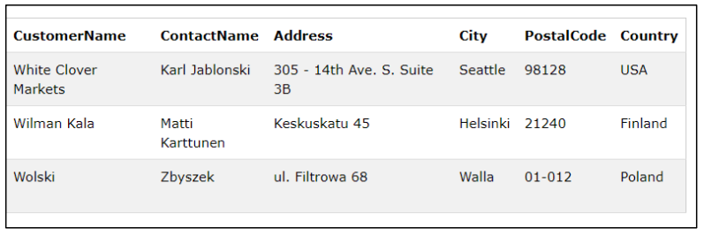

Tambahkan data customers berikut pada tabel diatas!

|  |  |  |  |  |  |
| --- | --- | --- | --- | --- | --- |
| **CustomerName** | **ContactName** | **Address** | **City** | **PostalCode** | **Country** |
| Cardinal | Erichsen | Skagen | Stavanger | 4006 | Norway |